**13th WEEK IN ORDINARY TIME**

**EVENTS IN THE PARISH FOR THE WEEK**

**Sun:- Baptisms during 12.00m Mass.**

**Fayre from 2.00 – 6.00**

**Mon:- Parish Office closed**

**Tues:- Exposition of the Blessed Sacrament during the day.**

**Thurs. - Legion of Mary meeting in the Ruah Centre at 10.30 am**

**Pilates in the Ruah Centre at 9.30 am contact Grainne**

**On 087 3892750**

**Fri. - First Friday. Padua group to bring Communion to the**

**House bound.**

**Pre-Marriage Course in Ruah Centre 6.30 pm**

**Sat:- Pre-Marriage Course in Ruah Centre.**

**\* * * * * * * * * * * * * ** * * * * * * * * * * * \***



**-The Midsummer Fayre takes place this afternoon from 2.00 – 6.00 pm in the Church grounds. There will be live music, Bouncy Castles, Basketball demos, Face painting, live dancing, a Craft Fair, a Dog Show and much, much more…… Adults €5.00, Teens €2.00 and kids free. All children must be accompanied by an adult. Let’s pray for a warm, sunny day.**

**-Congratulations to all the boys and girls from Ballyroan Boys’ School and Scoil Naomh Padraig who had their graduation Mass on Wednesday. We wish them every happiness as they begin their new adventure in Secondary schools in September. We wish the staff and students a very happy summer holiday.**

**-As this coming Friday is the 1st Friday, we invite the members of the Padua Society to attend the 10.00 Mass before bringing Holy Communion to the sick and the housebound.**

**SUMMER SCHEDULE:**

**-The parish office will open on Tuesdays, Wednesdays and Thursdays ONLY.**

**-The Newsletter in its present format will resume in September.**

**-The 7.30 Morning Prayer will also resume in September.**

**-A full day workshop will take place in Avila Retreat Centre, Morehampton Road, on 18th July. The theme for the day is The Joy of the Gospel by Pope Francis.**

**-The family of Edwin Homan wish to thank all the parishioners who assisted him when he became ill in the church. He is now doing well in hospital.**

**THE PETER’S PENCE, PONTIFICAL CHARITIES COLLECTION WILL REPLACE THE SHARE COLLECTION THIS WEEKEND.**

**Readers for NEXT weekend**

**7.00 pm: Winnie Keogh**

**10.00 am: Anne Walsh**

**Brenda Warren**

**Eileen Goodwin**

**12.00 Irene heeney**

**Pauline Ryan**

**Maeve Duffy**

**Priest of the Parish: Fr Brendan Madden Parish Office:014947303 Email:**[**ballyroanparish@gmail.com**](mailto:ballyroanparish@gmail.com)**Website:** [**www.ballyroanparish.ie**](http://www.ballyroanparish.ie)

Church of the Holy Spirit, Ballyroan

**MASS INTENTIONS**

**Sat 7.00 pm-Dan Gallagher (A) and John Cleary (A); Sun. 10.00-Peter McNally (A), Mary Fitzmaurice (A) and John Kavanagh (A); 12.00-Frank Healy (Month’s Mind); Mon. 10.00-Maureen and Micheal Dorr (A) ; Tues. 10.00-Dermot O’Looney (A) and Eva Fitzpatrick (A); Wed 10.00-Paul Ring (A); Thurs 10.00-Paddy Gilligan (Get well Mass): Fri. 10.00-Altar List for the Dead.**

**Anniversaries: Joan Mulrooney, Dermot O’Looney and Eva Fitzpatrick.**

**Recently deceased: Andrew Donagher**

**FEAST DAYS FOR THE WEEK**

**Mon: Ss. Peter and Paul, apostles**

**Tues: The first Martyrs of Rome**

**Wed: St Oliver Plunkett, bishop**

**and martyr**

**Fri: St. Thomas, apostle**

**Sat: St. Elizabeth of Portugal**

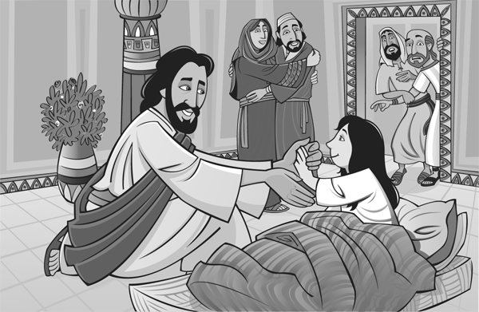

**If we have faith great things can happen…**

**Last week, the apostles brought Jesus with them in the boat and he calmed the storm.**

**This week, we are amazed at the faith of the woman and the official, Jairus and Jesus was amazed too.**

**Lord, may we always invite you to come with us on our journey, increase our faith so that we may never be afraid to ask you for favours like Jairus did or to touch your garment like the woman did.**

**We pray for all the Peters, Pauls, Olivers, Thomas and Elizabeths in the parish, may they be held close to you and may their faith be renewed and increased.**

**Amen.**

**Readers for THIS weekend**

**7.00 pm: Hilary Kenny**

**Gerry Moore**

**10.00am: Joan McCarthy**

**Pauline Ryan**

**Anne Keane**

**12.00: Moira O’Brien**

**Mary Vaughan**

**Grainne Hagan**

**Readers for this weekend**

**7.00 pm: Mary Vaughan**

**TH Betty O’Carroll**

**10.00: Aine Vaughan**

**Therese Waterman**

**Anne Keane**

**12.00: Frank Browne**

**Luke Bradley**

**Ann Proctor**