.  General Data Protection Regulation (GDPR)  This information will be kept in relation to your child’s Baptism. After the Baptism, the copy of your child’s birth certificate will be destroyed.  But we would like to be able to occasionally contact you, regarding parish activities. Please tick the relevant box below if you are happy for us to do so.  Yes No  Signature  Date  Jesus was baptized by John the Baptist in the River Jordan and experienced the Holy Spirit-and so began his ministry.  Painting in our Church by Seán Keating 1967 |  |  | 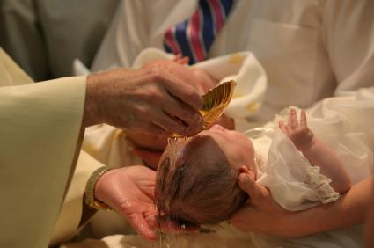  Ballyroan Parish  Church of the Holy Spirit  Baptism Form  www.ballyroanparish.ie  01-4947303

Congratulations to you and your family on the birth of your child. We would be delighted to have the opportunity to celebrate the Sacrament of Baptism with you.  How to make a booking for a Baptism  - Ring our parish office on 01-4947303 and a member of the parish team will contact you regarding this form and the required additional information.  - A member of the Baptism team will make an appointment to speak to you and give you some information about Baptism and the ceremony.  - Please give the parish about six weeks’ notice to plan for your child’s Baptism.  - Please complete the form using block letters or type a downloaded copy from our parish website.  - You will need to give us a copy of your baby’s Birth Certificate.  - Ideally, you should live or have a close connection within our parish. |  |  | Baptism Registration Form  Child’s Name  Date of Birth  Father’s Name  Mother’s Maiden Name  Address  Contact Number  Email  Date and place of Marriage  Name of Godparent (1)  Name of Godparent (2)  Office Use  Date of Baptism  Celebrant

